1. Add Two Objects and Declare values program in C

#include <stdio.h>

struct A {

int value;

};

struct A addObjects(struct A x, struct A y) { // Function to add two objects

struct A result;

result.value = x.value + y.value;

return result;

}

int main() {

struct A x; // Declare and initialize objects

struct A y;

x.value = 10;

y.value = 20;

struct A result = addObjects(x, y);

printf("The sum of x and y is: %d\n", result.value);

return 0;

}

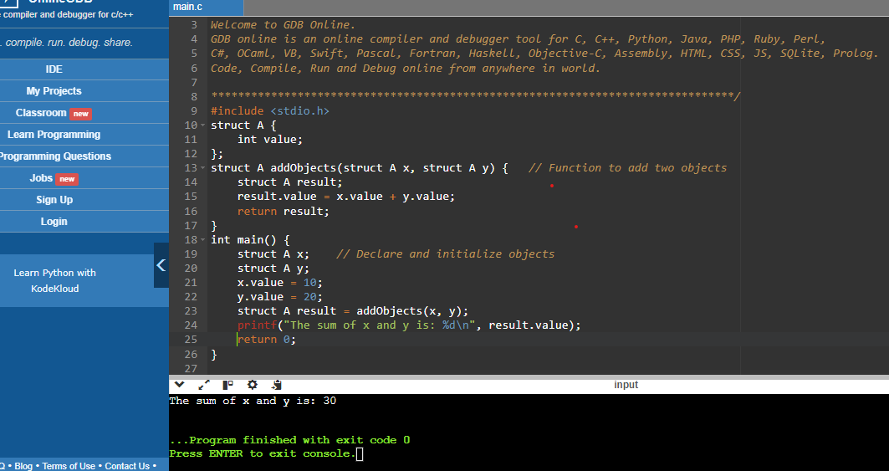

1. What are the benefits and drawbacks of operator overloading?

A: Benefits:

* Improved Readability and Intuition: Overloading operators can make user-defined types easier to use and more intuitive.
* Consistency with Built-in Types: It allows custom types to be used similarly to built-in types, maintaining consistency and making code easier to understand.
* Encapsulation and Abstraction: Operator overloading can help encapsulate complex operations within a class, allowing users to work with higher-level abstractions without needing to understand the underlying implementation.
* Enhanced Usability: User-defined types become more versatile and can be used more naturally in expressions and algorithms, promoting code reuse.

Drawbacks:

* Potential for Misuse and Confusion: Overloading operators in non-intuitive ways can lead to confusion and make the code harder to understand.
* Maintenance Complexity: Overloaded operators can sometimes obscure the logic of the program, making it harder to maintain and debug, especially if the behavior deviates from conventional expectations.
* Performance Considerations: Operator overloading can introduce performance overhead if not implemented efficiently, particularly for complex operations. This can be a concern in performance-critical applications.
* Limited Operator Set: Not all operators can be overloaded (e.g.,. (member access),?: (ternary conditional), size of, etc.). This limitation means some syntactic benefits can't be achieved for all operations.
* Interoperability Issues: Overloaded operators might not always work well with other libraries or frameworks, especially if those libraries have their own expectations or implementations for certain operations.

2. Can you overload the assignment operator (=) in C++? If so, how would you ensure proper behavior?

A: The assignment operator,”=”, is the operator used for Assignment. It copies the right value into the left value. Assignment Operators are predefined to operate only on built-in Data types.

* Assignment operator overloading is binary operator overloading.
* Overloading assignment operator in C++ copies all values of one object to another object.
* Only a non-static member function should be used to overload the assignment operator.

Example:

int a=5, b;

b = a;

cout<<b<<endl; //output: 5

3. Explain the difference between member function and non-member (friend) function overloading for operators.

A: In C++, both member operator functions and friend operator functions are used to overload operators for user-defined types. Here are the key differences between them:

1. **Member Operator Function**:  
   - A member operator function is a member function of a class that is used to overload an operator for that class.  
   - It must be a member of the class on the left-hand side of the operator.  
   - It has access to the private and protected members of the class.  
   - It is called with an implicit this pointer, referring to the object on the left-hand side of the operator.
2. **Friend Operator Function**:  
   - A friend operator function is not a member of the class but is declared as a friend of the class, allowing it to access the private and protected members of the class.  
   - It can be defined either inside or outside the class.  
   - It can be used to overload operators for types where the left-hand operand is not an object of the class.  
   - It is not called with an implicit this pointer.  
   - It does not have direct access to the members of the class unless explicitly granted through the friend declaration.

3. Design a class Vector2D and overload the arithmetic operators (+, -, *, /) for vector addition, subtraction, scalar multiplication, and division (by a scalar).

A: #include <iostream>

using namespace std;

class Vector2D {

public:

double x, y;

Vector2D() : x(0.0), y(0.0) {}

Vector2D(double x, double y) : x(x), y(y) {}

Vector2D add(Vector2D v) {

return Vector2D(x + v.x, y + v.y); }

Vector2D subtract(Vector2D v) {

return Vector2D(x - v.x, y - v.y); }

Vector2D multiply(double scalar) {

return Vector2D(x * scalar, y * scalar); }

Vector2D divide(double scalar) {

if (scalar != 0.0)

return Vector2D(x / scalar, y / scalar);

else {

cout << "Error: Division by zero!" << endl;

return Vector2D(); }

}

void display() {

cout << "Vector2D: (" << x << ", " << y << ")" << endl;

}

};

int main() {

Vector2D v1(7.5, 6.5);

Vector2D v2(2.5, 3.0);

Vector2D sum = v1.add(v2);

cout << "Sum: ";

sum.display();

Vector2D difference = v1.subtract(v2);

cout << "Difference: ";

difference.display();

Vector2D scaled = v1.multiply(2.0);

cout << "Scaled: ";

scaled.display();

Vector2D divided = v1.divide(2.0);

cout << "Divided: ";

divided.display();

return 0;

}

Output:

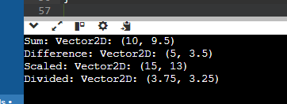

5. Is it possible to overload the comparison operators (==, !=, <, >, <=, >=) for custom classes? If so, what considerations should be taken into account?

A: Yes, it is possible to overload comparison operators (==, !=, <, >, <=, >=) for custom classes in C++. Here are some considerations and an example of how to do it:

Considerations:

1. Consistent Logic: Ensure that the logic for comparison operators is consistent and intuitive. For example, if a < b is true, then b > a should also be true.
2. Symmetry and Transitivity: Symmetry: If a == b is true, then b == a should also be true. Transitivity: If a == b and b == c, then a == c should be true.
3. Reflexivity: A value should be equal to itself, i.e., a == a should be true.
4. Operator Pairs: Implement related operators in pairs to ensure consistency. For example, if you overload ==, you should also overload !=.
5. Efficiency: Ensure the comparison operations are efficient, especially if they will be used frequently.

6. Can you overload the stream insertion (<<) and extraction (>>) operators for your Vector2D class to allow easy printing and reading from streams?

A:

7. Describe a scenario where overloading the logical operators (&&, ||, !) for a custom class might be useful.

### A: Scenario: User Access Control

### Consider a system where users have different access rights and roles. We might have a User Permissions class that encapsulates a user's permissions, such as read, write, and execute rights. Overloading logical operators for this class can be useful for combining and evaluating user permissions.

### Use Case: Access Rights Evaluation

* Logical AND (&&): Check if a user has all necessary permissions to perform a certain action.
* Logical OR (||): Check if a user has at least one of the required permissions to access a resource.
* Logical NOT (!): Check if a user is missing any permissions.

8. Discuss the potential ambiguity that could arise when overloading the subscript operator ([]) for a class. How can this ambiguity be resolved?

A: Overloading the subscript operator ([]) for a class can lead to potential ambiguities, particularly when dealing with both const and non-const objects. Here’s a detailed discussion of the potential issues and how to resolve them:

Potential Ambiguities

1. Const vs. Non-Const Objects: When you overload the subscript operator, you need to consider how it behaves for both const and non-const objects. A non-const object

Should allow modification of the elements, while a const object should only allow read access.

1. Return Type Differences: The return type of the subscript operator can also lead to ambiguity. For a non-const object, you typically return a reference to allow modification, while for a const object, you return a const reference to prevent modification.

Resolving Ambiguity: To resolve these ambiguities, you should provide two versions of the subscript operator: one for const objects and one for non-const objects.

9. Can operator overloading be used to implement the concept of immutability (unchanging state) for a class? Explain your answer.

A: Operator overloading itself cannot directly implement the concept of immutability (unchanging state) for a class, but it can be used to support and enforce immutability when combined with other language features and design patterns. Here's an explanation of how this can be achieved:

Immutability in C++ : Immutability means that once an object is created, its state cannot be changed. In C++, this can be enforced by: Making all member variables const. and Providing only const methods (including overloaded operators) that do not modify the state.

Using Const Methods and Operators

When you overload operators for a class that should be immutable, you should ensure that these operators do not modify the object’s state. This is done by declaring the operators as const methods.

10. When overloading operators, what are some best practices to ensure code clarity and maintainability?

A: When overloading operators in C++, following best practices is essential to ensure code clarity and maintainability. Here are some key guidelines:

1. Follow Conventional Meanings: Stick to conventional meanings: Overload operators in ways that align with their conventional use. For instance, + should perform addition, [] should perform indexing, etc..

2. Preserve Operator Semantics: Consistency-Ensure that the overloaded operators preserve the semantics of the corresponding built-in operators. For example, if you overload ==, it should provide a meaningful equality comparison.

* Symmetry: If you overload ==, also consider overloading !=. If you overload <, you might also need <=, >, and >=.

3. Provide Both Member and Non-Member Functions: Member vs. non-member: Operators like += and [] are typically overloaded as member functions, while others like + and == are often better as non-member functions to allow symmetric behavior (e.g., a + b where a is an instance of your class and b is not).

4. Return Values Appropriately

* Return by reference where appropriate: For operators like [] that need to allow modification, return by reference.
* Return by value: For operators like +, which create a new object, return by value to ensure the new object is a distinct instance.

5. Ensure Const-Correctness: Const correctness: Make sure that overloaded operators that do not modify the object are marked as const. Const versions: Provide both const and non-const versions of operators where necessary.

11. What is the core concept behind function overloading?

A: Function overloading is a feature of object-oriented programming where two or more functions can have the same name but different parameters. When a function name is overloaded with different jobs it is called Function Overloading. In Function Overloading “Function” name should be the same and the arguments should be different. Function overloading can be considered as an example of a polymorphism feature in C++. If multiple functions having same name but parameters of the functions should be different is known as Function Overloading.

12. How does the compiler differentiate between overloaded functions with the same name?

A: The compiler differentiates between overloaded functions (including overloaded operators) primarily based on the function signature, which includes the function name and its parameter list. Here’s how the compiler distinguishes between overloaded functions with the same name:

Function Signature

The function signature consists of:

1. Function Name: This is the name of the function.
2. Parameter List: This includes the type, order, and number of parameters (including their const and volatile qualifiers).

### Function Resolution: When the compiler encounters a function call, it selects the appropriate function to call based on the following steps: **Exact Match**, **Promotion**, **and Standard Conversion, User-Defined Conversions**

### 13. Can functions with different return types be overloaded? Explain your reasoning.

### A: No, functions with different return types cannot be overloaded in C++. Overloading in C++ is based on the function signature, which includes the function name and its parameter list. The return type is not part of the function signature for the purpose of overloading.

### Example:

### int add(int a, int b) {

### return a + b;

### } double add(int a, int b) {

### return a + b; }

In this example, both functions add have the same name (add) and the same parameter list (int, int). The only difference is their return type (int vs double). Attempting to compile such code would result in a compilation error because C++ does not allow overloading based on return type.

14. Design a function print Value that can handle different data types (e.g., int, double, std::string) by overloading it with appropriate parameter lists.

#include <iostream>

#include <string>

using namespace std;

void printValue(int value) {

cout << "Integer value: " << value << endl; }

void printValue(double value) {

cout << "Double value: " << value << endl; }

void printValue(const std::string& value) {

cout << "String value: " << value << endl; }

int main() {

int intValue = 10;

double doubleValue = 3.14;

string stringValue = "Hello, World!";

printValue(intValue);

printValue(doubleValue);

printValue(stringValue);

return 0;

}

Output:

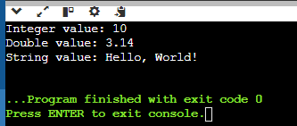

15. Discuss the advantages and disadvantages of using default arguments in overloaded functions.

A: **A default argument in C++ is a value written in the function declaration which gets automatically assigned to the parameter if the calling function doesn't provide a value for that argument.**

Advantages & Disadvantages:

Following are some major advantages of default arguments in C++:

1. We can increase the capabilities of an existing function as we can do it just by adding another default argument to the function.
2. It can reduce the program size.
3. It is a simple and effective programming approach.
4. It can improve the consistency of a program

The only disadvantage is that it increases the execution time as the compiler needs to replace the omitted arguments with their default values in the function call.

16. In the context of function overloading, explain the concept of argument promotion and implicit type conversion.

A: In the context of function overloading, argument promotion and implicit type conversion are mechanisms used by the C++ compiler to match function calls to the appropriate overloaded function based on the provided arguments.

### Argument Promotion

**Argument promotion** refers to the automatic conversion of a function argument to a larger or wider type if needed by the function parameter type. This typically happens with built-in types such as integers, characters, and floats. Argument promotion rules ensure that function calls can match overloaded functions with parameters of different sizes or types.

### Implicit Type Conversion

**Implicit type conversion** refers to the automatic conversion of one type of data to another type without explicit user intervention. It allows the compiler to convert data from one type to another when calling functions or performing assignments, provided that the conversion is safe and meaningful according to C++'s type system.

17. When might it be a better idea to use separate functions with descriptive names instead of overloading a single function?

A: Using separate functions with descriptive names instead of overloading a single function can be a better approach in several scenarios where clarity, maintainability, and readability are priorities over the benefits of function overloading.

18. Can function overloading be used to achieve polymorphism (the ability to treat objects of different derived classes in a similar way)? Explain.

A: Yes, function overloading can contribute to achieving polymorphism in C++. Polymorphism refers to the ability to treat objects of different derived classes through a common interface or base class pointer or reference.

How Function Overloading Supports Polymorphism: **Base Class Interface,** Function Overloading with Virtual Functions, Dynamic Binding, Uniform Access.

19. Describe a scenario where overloading a function with a variable number of arguments (varargs) could be beneficial.

A: Imagine you're developing a calculator application. You want a single function calculate that can handle different numbers of inputs for various operations like addition, subtraction, and multiplication. By overloading calculate, you can create versions that accept different numbers of arguments—like two for addition, three for multiplication, and so on—making it easy for users to perform calculations with varying complexity without needing separate functions for each operation. This approach simplifies the interface and makes the calculator more versatile for different user needs.

20. Compare and contrast function overloading with virtual functions in C++ inheritance. Which approach is more suitable for specific use cases?

pen_spark

tune

share

more_vert

**CODING PART**

Operator Overloading

1. Complex Numbers (C++) - Define a class Complex to represent complex numbers with member variables for real and imaginary parts. Overload the +, -, and * operators for complex number addition, subtraction, and multiplication.

#include <iostream>

using namespace std;

class Complex {

private:

double a; // Real part

double b; // Imaginary part

public:

Complex(double real = 0.0, double imag = 0.0) : a(real), b(imag) {}

Complex operator+(Complex& other) {

return Complex(a + other.a, b + other.b); } // Overloading + operator for addition

Complex operator-(Complex& other) {

return Complex(a - other.a, b - other.b); } // Overloading - operator for subtraction

Complex operator*(Complex& other) {

return Complex(a * other.a - b * other.b, // Overloading * operator for multiplication

b * other.a + a * other.b); }

void display() const {

cout << "(" << a << " + " << b << "i)" << endl; // Display function

} };

int main() {

Complex c1(2.0, 3.0);

Complex c2(1.0, -1.0);

Complex sum = c1 + c2;

Complex diff = c1 - c2;

Complex prod = c1 * c2;

cout << "Complex Number 1: ";

c1.display();

cout << "Complex Number 2: ";

c2.display();

cout << "Sum: ";

sum.display();

cout << "Difference: ";

diff.display();

cout << "Product: ";

prod.display();

return 0;

}

OUTPUT:

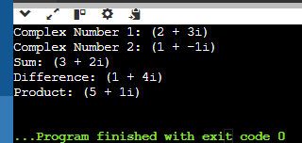

2. Point2D - Create a class Point2D with x and y coordinates. Overload the + operator to return a new Point2D object representing the sum of two points.

A: #include <iostream>

using namespace std;

class Point2D {

private:

int x;

int y;

public:

Point2D(int xCoord = 0, int yCoord = 0) : x(xCoord), y(yCoord) {}

Point2D operator+(const Point2D& other) const {

return Point2D(x + other.x, y + other.y); } // Overloading + operator for addition of two points

void display() const {

cout << "(" << x << ", " << y << ")" << endl; } // Display function to print the coordinates of the point

};

int main() {

Point2D p1(2, 3);

Point2D p2(1, -1);

Point2D sum = p1 + p2;

cout << "Point 1: ";

p1.display();

cout << "Point 2: ";

p2.display();

cout << "Sum of Points: ";

sum.display();

return 0;

}

OUTPUT:

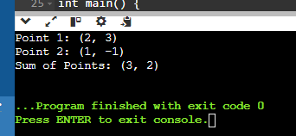

3. Time - Design a class Time to store hours, minutes, and seconds. Overload the + operator to add two Time objects and return a new Time object with the combined duration.

A: #include <iostream>

using namespace std;

class Time {

private:

int hours;

int minutes;

int seconds;

public:

Time(int h = 0, int m = 0, int s = 0) : hours(h), minutes(m), seconds(s) {}

Time operator+(const Time& other) const {

int totalSeconds = seconds + other.seconds; // Overloading + operator

int carryMinutes = totalSeconds / 60;

totalSeconds %= 60;

int totalMinutes = minutes + other.minutes + carryMinutes;

int carryHours = totalMinutes / 60;

totalMinutes %= 60;

int totalHours = hours + other.hours + carryHours;

return Time(totalHours, totalMinutes, totalSeconds);

}

void display() const {

cout << hours << " hours, " << minutes << " minutes, " << seconds << " seconds" << endl;

} };

int main() {

Time t1(2, 30, 45);

Time t2(1, 15, 20);

Time sum = t1 + t2;

cout << "Time 1: ";

t1.display();

cout << "Time 2: ";

t2.display();

cout << "Sum of Times: ";

sum.display();

return 0;

}

OUTPUT:

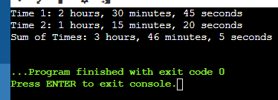

4. Date - Implement a class Date with year, month, and day. Overload the comparison operators (== and !=) to compare two Date objects.

A: #include <iostream>

using namespace std;

class Date {

private:

int year;

int month;

int day;

public:

Date(int y, int m, int d) : year(y), month(m), day(d) {}

bool operator==(const Date& other) const {

return year == other.year && month == other.month && day == other.day;

}

bool operator!=(const Date& other) const {

return !(*this == other);

}

};

int main() {

Date date1(2024, 6, 27);

Date date2(2024, 6, 27);

Date date3(2024, 6, 28);

if (date1 == date2)

cout << "Date 1 == Date 2" << endl;

else

cout << "Date 1 != Date 2" << endl;

if (date1 == date3)

cout << "Date 1 == Date 3" << endl;

else

cout << "Date 1 != Date 3" << endl;

if (date1 != date2)

cout << "Date 1 != Date 2" << endl;

else

cout << "Date 1 == Date 2" << endl;

if (date1 != date3)

cout << "Date 1 != Date 3" << endl;

else

cout << "Date 1 == Date 3" << endl;

return 0; }

OUTPUT:

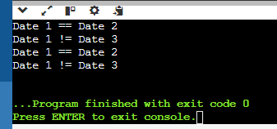

5.String Equality (C++) - Overload the equality operator (==) for a custom String class to compare string contents (not just memory addresses).

A: #include <iostream>

#include <cstring>

using namespace std;

class String {

private:

char* str;

public:

String(const char* s = "") {

str = new char[strlen(s) + 1];

strcpy(str, s);

}

String() {

delete[] str;

}

bool operator==(const String& other) const {

return strcmp(str, other.str) == 0;

}

};

int main() {

String s1("Hello");

String s2("Hello");

String s3("World");

if (s1 == s2)

cout << "s1 and s2 are equal" << endl;

else

cout << "s1 and s2 are not equal" << endl;

if (s1 == s3)

cout << "s1 and s3 are equal" << endl;

else

cout << "s1 and s3 are not equal" << endl;

return 0;

}

OUTPUT:

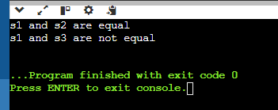

Function Overloading

6. Area Calculation - Create a function calculateArea that can handle different shapes (e.g., rectangle, circle) by overloading it with parameters like width, height, or radius.

A: #include <iostream>

#include <cmath>

using namespace std;

double calculateArea(double width, double height) {

return width * height; }

double calculateArea(double radius) {

return M_PI * pow(radius, 2); }

int main() {

double rectWidth = 5.0;

double rectHeight = 3.0;

double rectArea = calculateArea(rectWidth, rectHeight);

cout << "Area of rectangle: " << rectArea << endl;

double circleRadius = 2.5;

double circleArea = calculateArea(circleRadius);

cout << "Area of circle: " << circleArea << endl;

return 0;

}

OUTPUT:

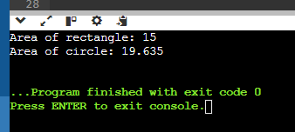

7. Unit Conversion - Design a function convert that takes a value and a unit (e.g., meters, feet, Celsius, Fahrenheit) and converts it to another unit using appropriate conversion factors.

A: #include <iostream>

using namespace std;

double celsiusToFahrenheit(double celsius) {

return (celsius * 9.0 / 5.0) + 32.0;

}

double fahrenheitToCelsius(double fahrenheit) {

return (fahrenheit - 32.0) * 5.0 / 9.0; }

int main() {

double celsiusValue = 20.0;

double fahrenheitValue = celsiusToFahrenheit(celsiusValue);

cout << celsiusValue << " Celsius is equal to " << fahrenheitValue << " Fahrenheit." << endl;

double fahrenheitValue2 = 68.0;

double celsiusValue2 = fahrenheitToCelsius(fahrenheitValue2);

cout << fahrenheitValue2 << " Fahrenheit is equal to " << celsiusValue2 << " Celsius." << endl;

return 0;

}

OUTPUT:

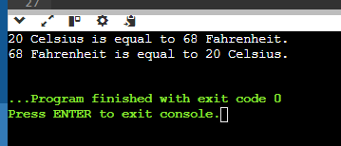

8. Statistics (C++) - Implement functions average, minimum, and maximum that can take an array of integers or doubles as input, depending on the function call.

A: #include <iostream>

#include <limits>

using namespace std;

int average(const int array[], int size) {

int sum = 0;

for (int i = 0; i < size; ++i) {

sum += array[i]; }

return sum / size; }

int minimum(const int array[], int size) {

int min = array[0];

for (int i = 1; i < size; ++i) {

if (array[i] < min) {

min = array[i]; }

} return min; }

int maximum(const int array[], int size) {

int max = array[0];

for (int i = 1; i < size; ++i) {

if (array[i] > max) {

max = array[i]; }

} return max ; }

int main() {

int intArray[] = {10, 5, 7, 3, 15};

int intSize = sizeof(intArray) / sizeof(intArray[0]);

cout << "Average of integers: " << average(intArray, intSize) << endl;

cout << "Minimum integer: " << minimum(intArray, intSize) << endl;

cout << "Maximum integer: " << maximum(intArray, intSize) << endl;

return 0;

}

OUTPUT:

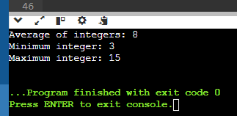

9. String Formatting (C#) - Write overloaded functions formatString that can take a format string and different data types (e.g., int, double, string) to create formatted output strings.

A: #include <iostream>

#include <sstream>

#include <string>

using namespace std;

namespace Formatter {

string formatString(const string& format, int value) {

ostringstream oss;

oss << format << value;

return oss.str();

} string formatString(const string& format, double value) {

ostringstream oss;

oss << format << value;

return oss.str();

} string formatString(const string& format, const string& value) {

ostringstream oss;

oss << format << value;

return oss.str();

}

} int main() {

string intFormatted = Formatter::formatString("The integer value is: ", 42);

string doubleFormatted = Formatter::formatString("The double value is: ", 3.14);

string stringFormatted = Formatter::formatString("The string value is: ", "Hello, World!");

cout << intFormatted << endl;

cout << doubleFormatted << endl;

cout << stringFormatted << endl;

return 0;

}

OUTPUT:

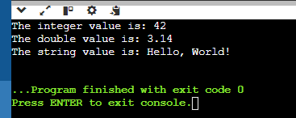

10. Math Functions - Create overloaded functions factorial and power that can handle integer and floating-point input for calculating factorials and raising a number to a power.

#include <iostream>

#include <cmath>

using namespace std;

namespace MathFunctions {

int factorial(int n) {

if (n < 0) {

throw invalid_argument("Factorial is not defined for negative numbers.");

}

int result = 1;

for (int i = 1; i <= n; ++i) {

result *= i; }

return result;

} int power(int base, int exponent) {

int result = 1;

for (int i = 0; i < exponent; ++i) {

result *= base;

}

return result;

} double factorial(double n) {

if (n < 0) {

throw invalid_argument("Factorial is not defined for negative numbers.");

}

return tgamma(n + 1);

} double power(double base, double exponent) {

return pow(base, exponent);

}

} int main() {

try {

cout << "Factorial of 5 (int): " << MathFunctions::factorial(5) << endl;

cout << "Factorial of 5.5 (double): " << MathFunctions::factorial(5.5) << endl;

cout << "2^3 (int): " << MathFunctions::power(2, 3) << endl;

cout << "2.5^3.5 (double): " << MathFunctions::power(2.5, 3.5) << endl;

} catch (const invalid_argument& e) {

cerr << "Error: " << e.what() << endl;

}

return 0;

}

OUTPUT:

